**Case study**

We are absolutely thrilled you are interested to join us at Rohlik. By now we have spoken to you about your experience and personality in great detail. Next step is to find out how you tackle a task in reality.

**Database Expert**

What would you recommend to do and we could discuss it with a broader audience next time ?

Consider following scenario

* MySQL Server 8 (InnoDB) with principal, basically “monolithic” schema (cca 1000 tables)
* 15 other system schemas / databases (per microservice)
* 60 applications using MySQL DB, most of them principal schema (1).
* applications itself are (with exception of database) designed as micro services
* one main schema “rohlik” occupying 85% of disk size
* Disc space occupied 1,5 TB (+ cca 100 G for logistic DB which is running on another server)
* We have separated databases per each country where rohlik operates
* Country databases are the same structure (holding country specific data)
* In Czech rep. we distribute approx 25 000 orders every day, provided metrics are for CZ databases - just to have some raw idea about the performance.
* Our plan is to be able to delivery 1M order across all countries, we can expect in biggest countries around 200 000 orders daily (that is estimated load to one country DB)
* Main schema rohlik contains around 1000 tables – the biggest tables (by size) are as follows (just to give you some overview how its unbalanced):

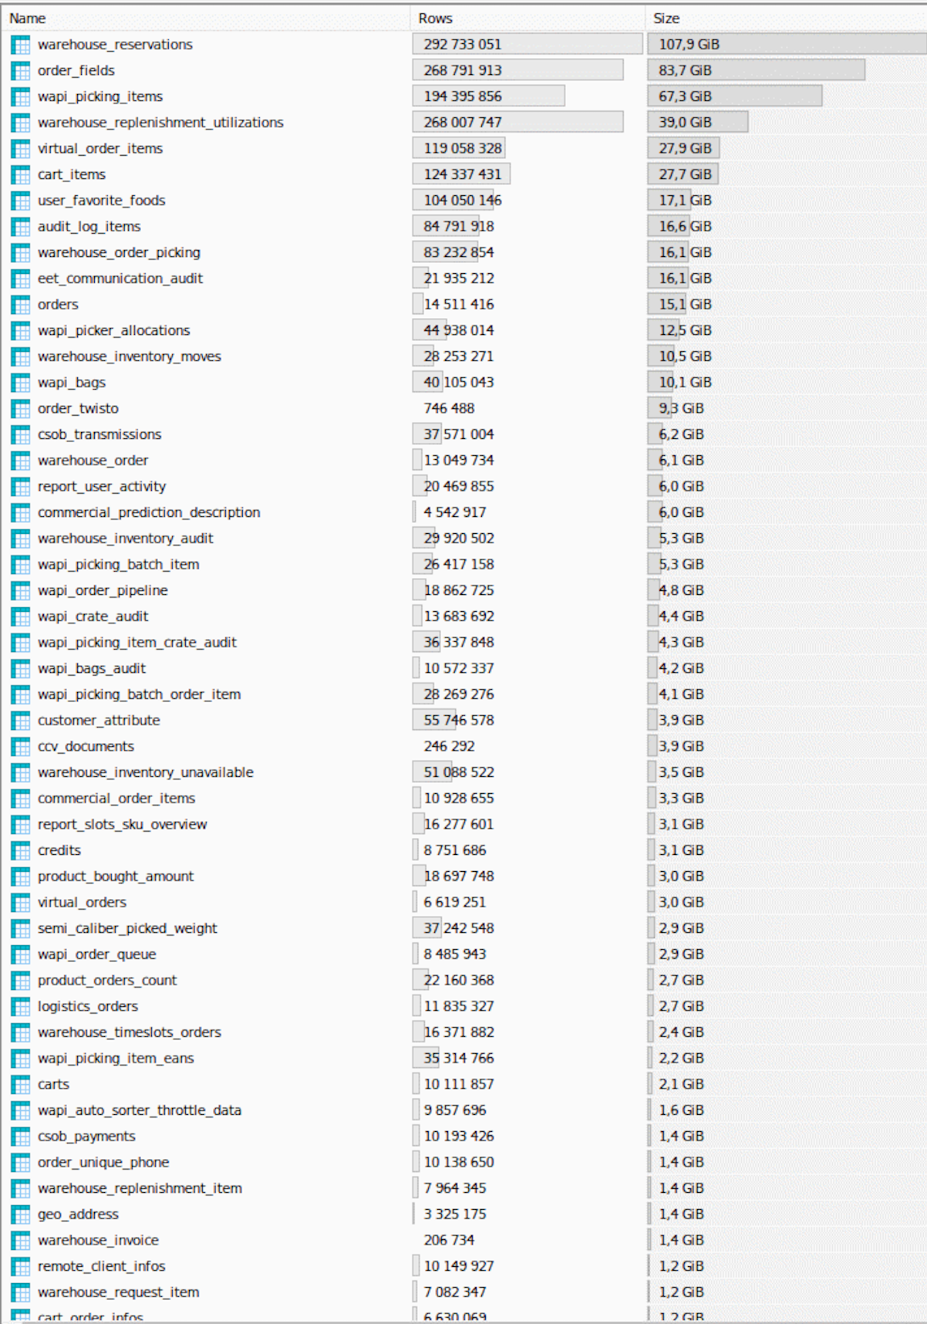Current "architecture" of the main CZ rohlik DB is:

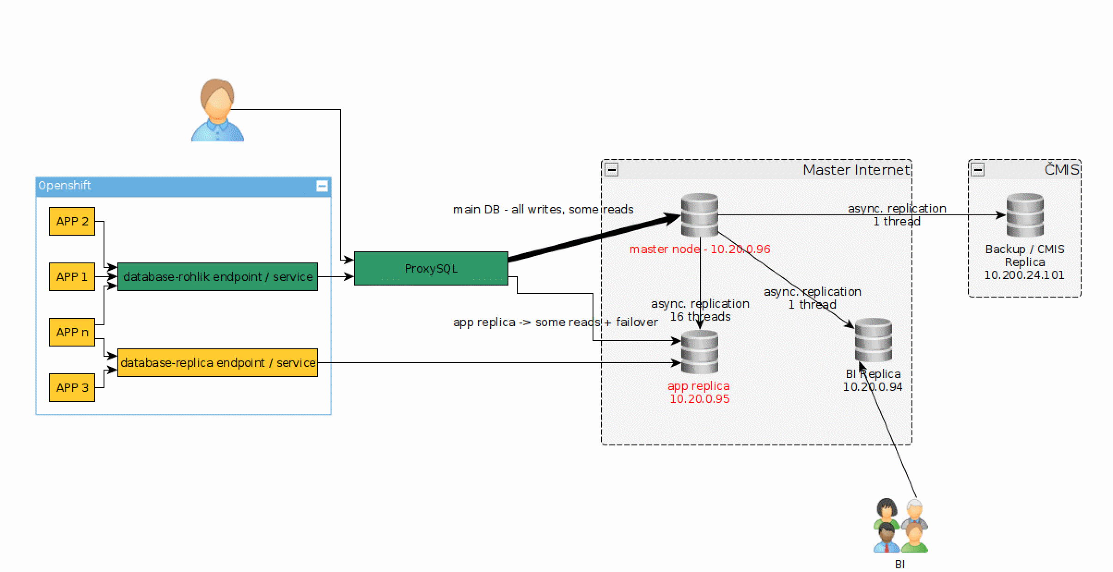

Consider workload of database illustrated by few following metrics for last 24 hours as sample (left is master, right is app replica):

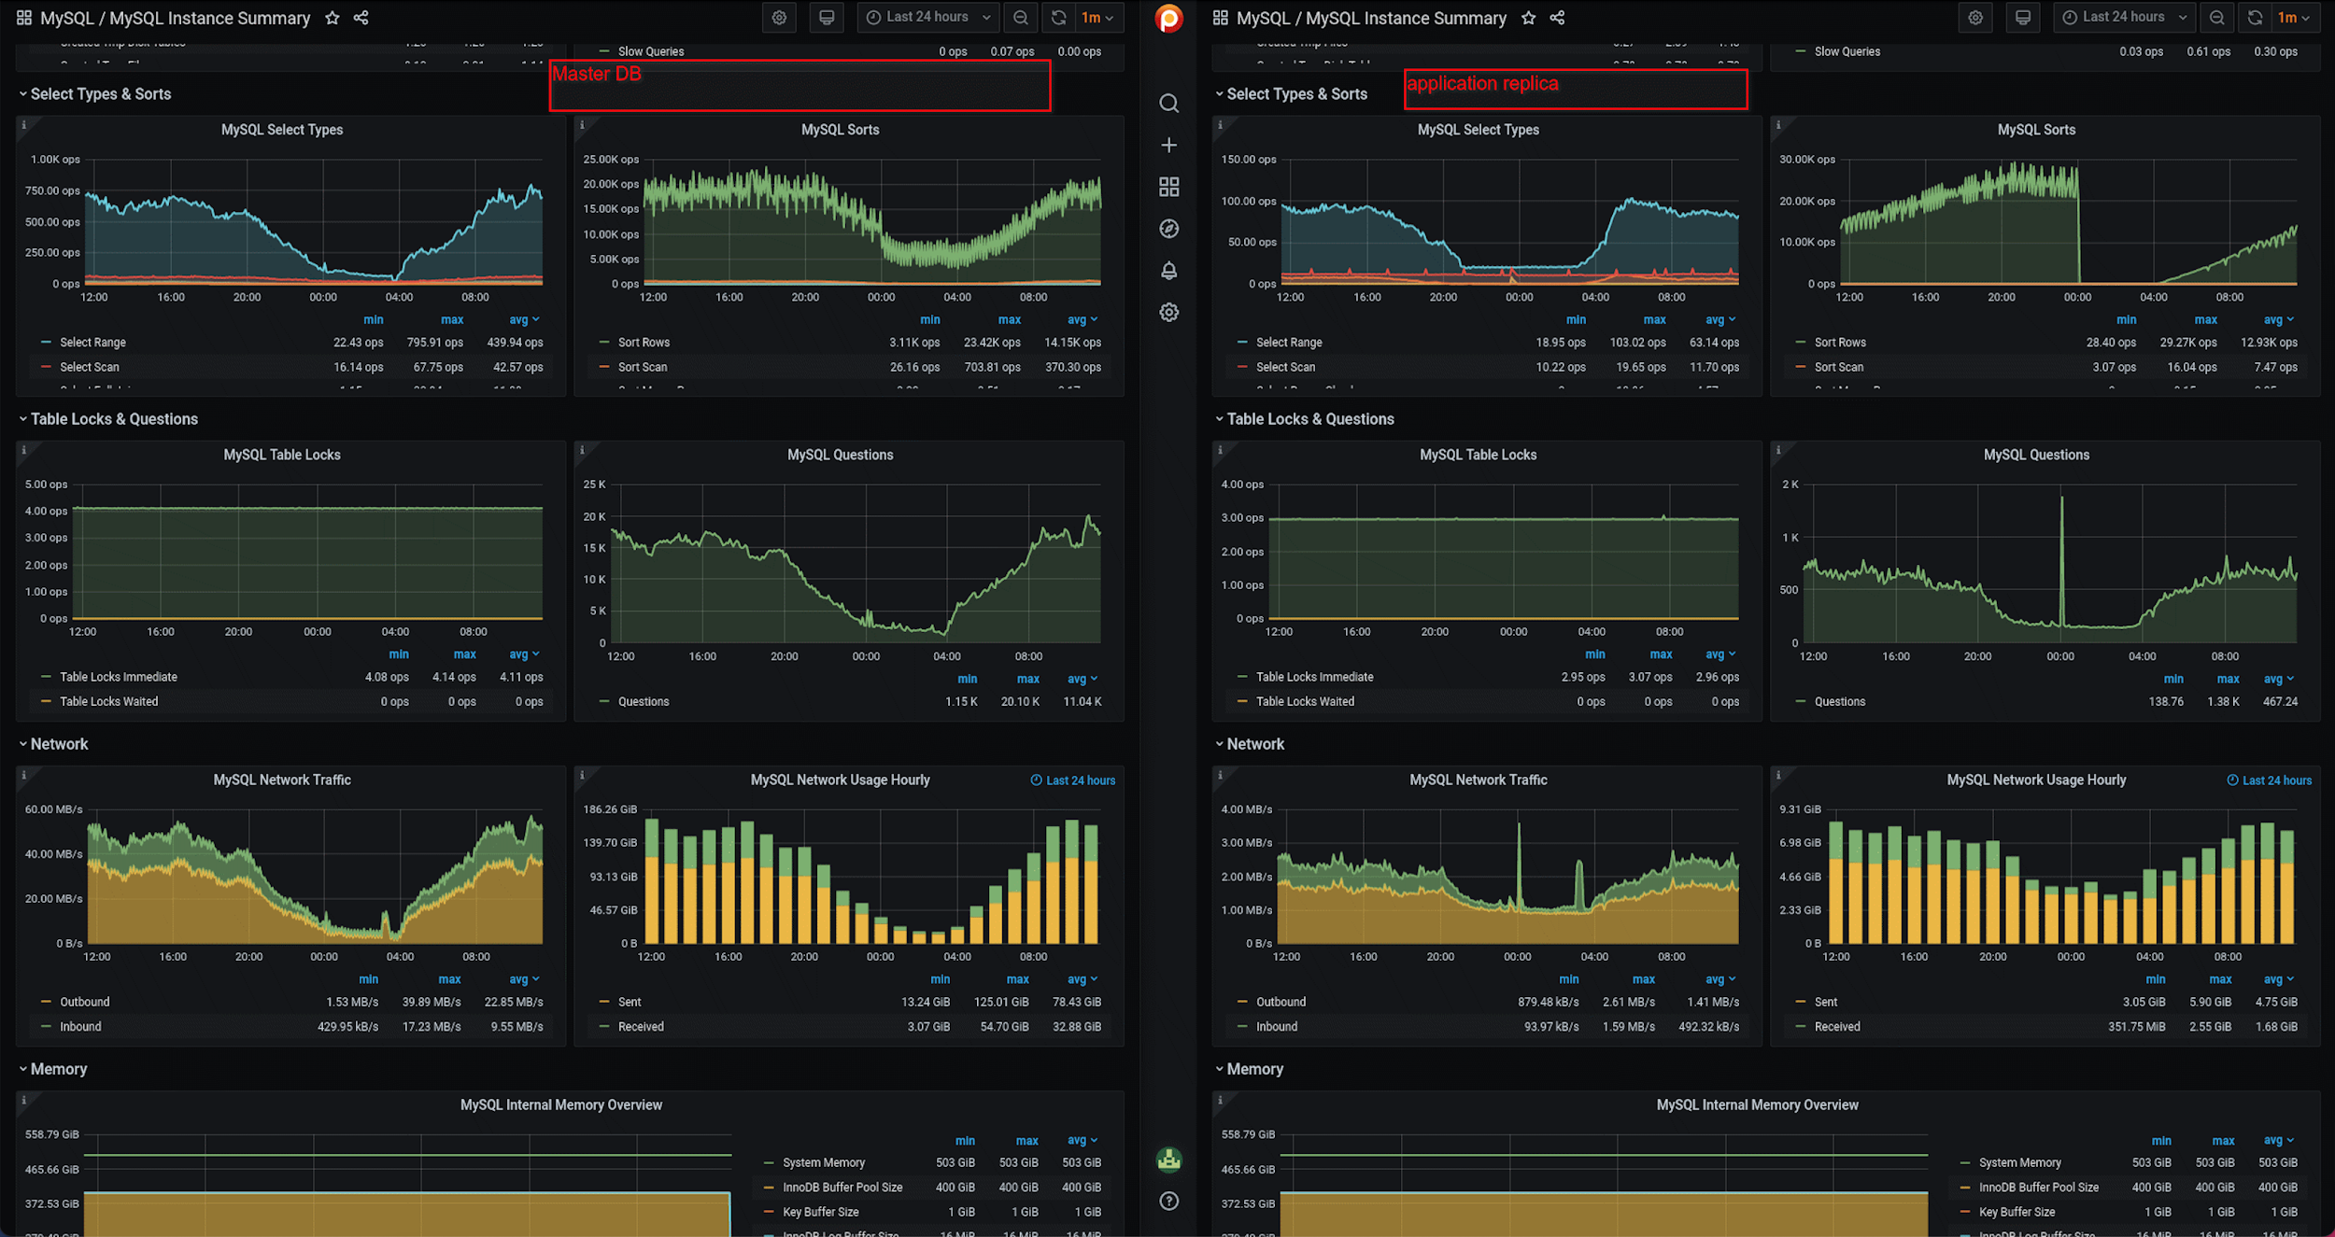

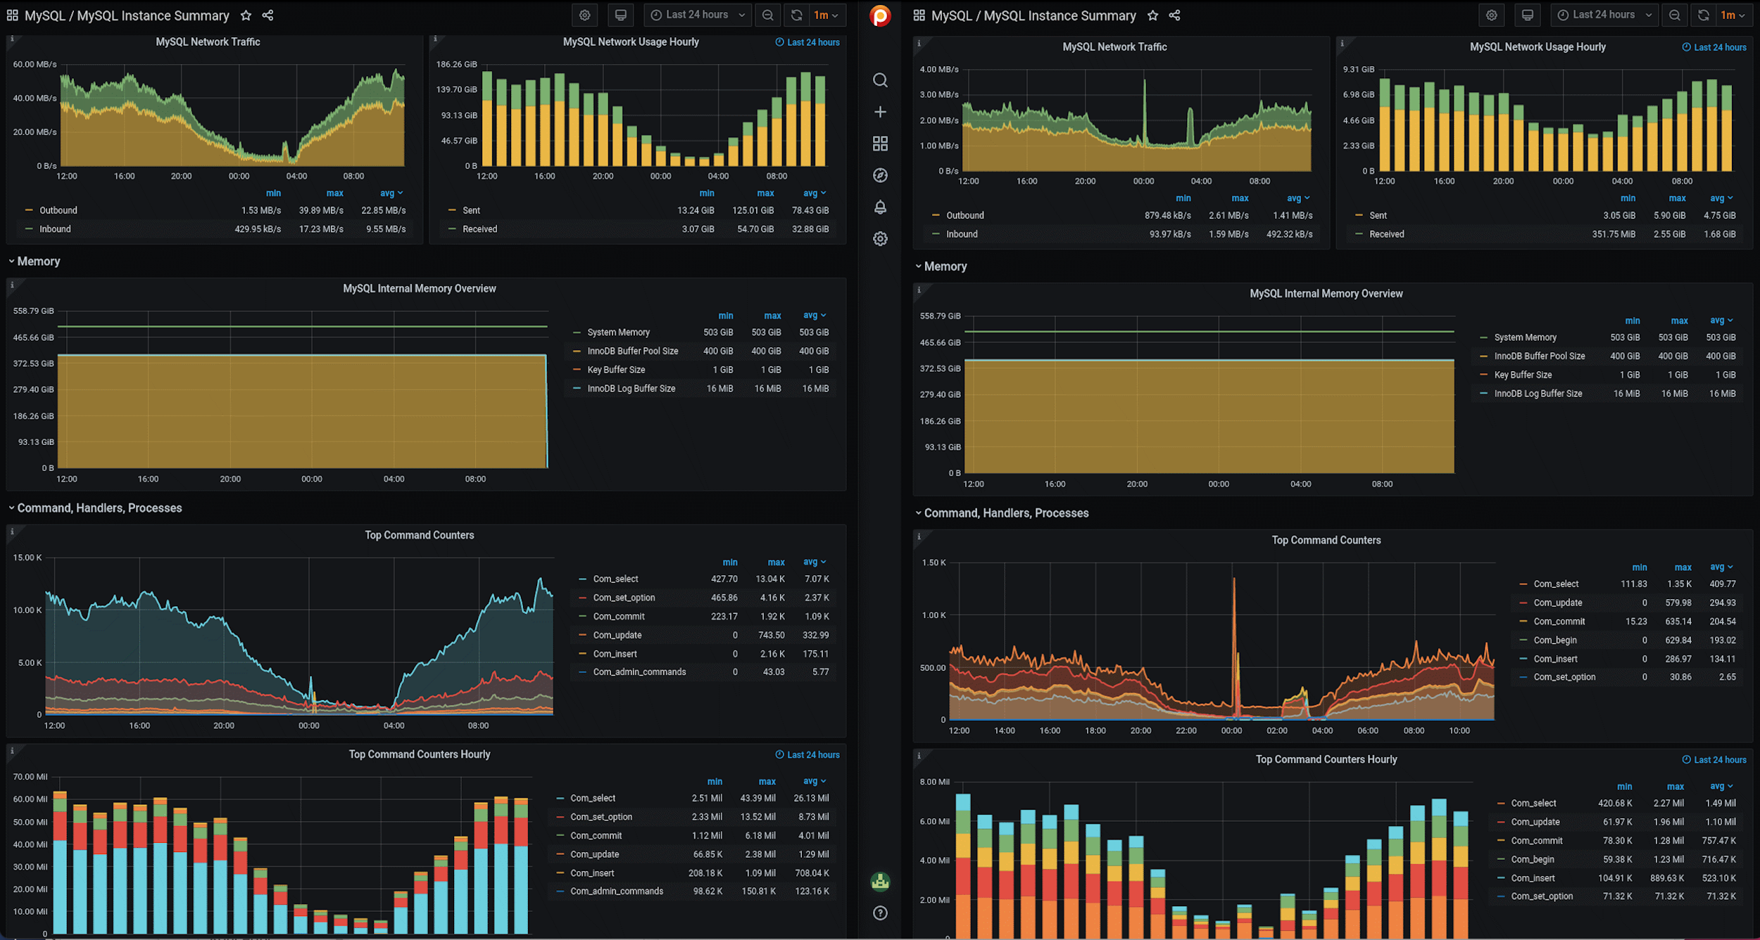

Topics we'd like to discuss:

1. Do you need more input ? What ?
2. How to improve overall availability of DB
   1. its required to be able to run 24/7. Therefore if possible, its required to operate with DB even during maintenance / upgrades etc
   2. In case of DB failure, we need as fast failover as possible. What would be your design ?
   3. just a note: we don't have good experiences with Galera cluster.
   4. Consider:  
      we use ProxySQL but everything is allowed, e.g. keepalived, HAProxy, MySQLRouter, etc … Easier to stay with Percona MySQL but not mandatory.
3. Performance improvements
   1. all necessary information are available (slow log, pmm / query analytics, …).
   2. How would you proceed with improving DB's performance.
   3. except application changes / query tunning (which might be time demanding process), what would be your steps on DB side with proposed architecture
   4. basically what would you do as "quick wins"
4. HA

As rohlik grows, every minute of outage becomes more and more expensive for us (not just the website but warehouses. logistic are now affected by db outages)

We plan to:

- unify our applications to serve requests from countries (now its separated openshift deployment per each country).

- have production infrastructure ready in another independent data center (or cloud ?) for immediate failover (or perhaps maybe even for load balancing)

What would be your design here (DB related) ?